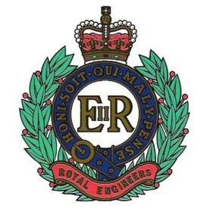 | The Royal Engineers Association |  |  | 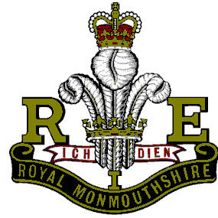
SERVICE NOT SELF |  | PATRON: HER MAJESTY THE QUEEN | CITY OF SWANSEA

Chairman:  Capt (Retd) BD Lawes MBE  64 Lon Coed Bran  Cockett  Swansea  SA2 0YD | President  Mr Tony Rowlands  256 Dunvant Road  Killay  Swansea  SA2 7SR | Secretary:  Mr A E Adams  Nant-y DDerwen  Brechfa  Carms  SA32 7BL

Tel: 01792 547644  Email: b.lawes1@ntlworld.com | Tel: 01792 536108  E-mail: tonii@ntlworld.com | Tel: 01267 202467  Email: anthonyadams186@sky.com

October 2018 Newsletter

So, summer has left us but it’s still trying to hang on. It won’t win though. Unlike Norwich City who have recently found a way of not losing. Hurrah for the Canary’s. Swans are ok.
Next up for the Branch, Sunday lunch at Sketty Hall on 12th of Oct, are you going? Let me know by October’s meeting on the 9th. Sorted out your plans for the Branch Christmas lunch? All payments for those attending must be in to Roger Jones prior to the event. Any dietary requests please let me know soonest.

Remembrance (Sunday)
There are two venues for you to choose from. The Cenotaph or Christchurch on Oystermouth road. The service in Christchurch starts at 09.30 with a short interlude for tea/coffee and then into the Remembrance service. Tony Adams will be leading the Branch contingent here whilst I along with David Hopkins (Standard bearer) will be at the Cenotaph at the wreath laying ceremony. You are welcome to attend either.
I would then like to see more than usual number of members attending St Marys for Swansea’s Remembrance service at 14.30. Yes, I know it’s a long day but our forebearers suffered even longer for us.

Attendees (Sept)
Brian Lawes, Tony Adams, Bryan Criddle, David Hopkins, Roger Jones, Tony Rowlands, Andy Thomas, Ron Horsey, Mansel Smith, Ossie Simmons, Nick Beverley, Bob Hunter, David Evans, KJ Evans and Dave Davie.

Apologies (Sept)
George Elliott, Harry Knight, Peter Wade, Dick Pelzer.

Pompeii

Did you know that 1939 years ago on the 27th of October, Mount Vesuvius erupted killing many of the inhabitants of Pompeii.
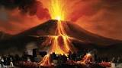
The total inhabitants of the cities were 16,000–20,000; the remains of about 1,500 people have been found at Pompeii and Herculaneum, but the overall death toll is unknown

A description of this terrible event can be likened to a pine tree; for it shot up to a great height in the form of a tall trunk, which spread out at the top as though into branches. Occasionally it was brighter, occasionally darker and spotted, as it was either more or less filled with earth and cinders.
Investigators reconstruct the sequence of volcanic events as follows. On the first day of the eruption a fall of white pumice containing fragments of up to 3 centimeters (1 in) fell for several hours. It heated the roof tiles to 120–140 °C (250–280 °F). This period would have been the last opportunity to escape. Subsequently, a second column deposited a grey pumice with clastic rocks up to 10 cm (4 in), temperature unsampled, but presumed to be higher, for 18 hours. These two falls were the Plinian phase. The collapse of the edges of these clouds generated the first dilute PDCs, which must have been devastating to Herculaneum, but did not enter Pompeii. Clastic rocks are composed of fragments, or clasts, of pre-existing minerals and rock. A clast is a fragment of geological detritus, chunks and smaller grains of rock broken off other rocks by physical weathering.
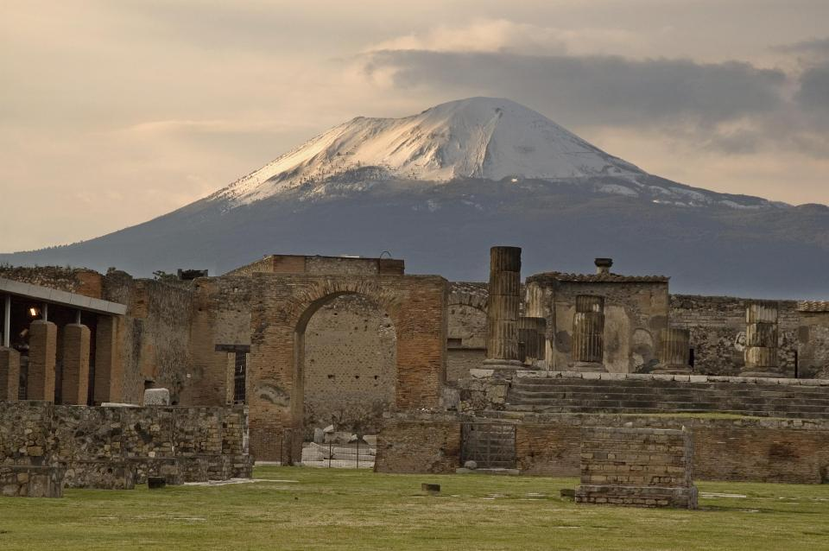
Early in the morning of the second day the grey cloud began to collapse to a greater degree. Two major surges struck and destroyed Pompeii. Herculaneum and all its population no longer existed. The emplacement temperature range of the first surge was 180–220 °C (360–430 °F), minimum temperatures; of the second, 220–260 °C (430–500 °F). The depositional temperature of the first was 140–300 °C (280–570 °F). Upstream and downstream of the flow it was 300–360 °C (570–680 °F).
Mount Vesuvius spewed forth a deadly cloud of tephra and gases to a height of 33 kilometers (21 mi), ejecting molten rock, pulverized pumice and hot ash at the rate of 1.5 million tons per second, ultimately releasing 100,000 times the thermal energy of the Hiroshima-Nagasaki bombings. Pompeii was first rediscovered in 1748.
The volcano is still considered one of the most dangerous on earth.

Belfast
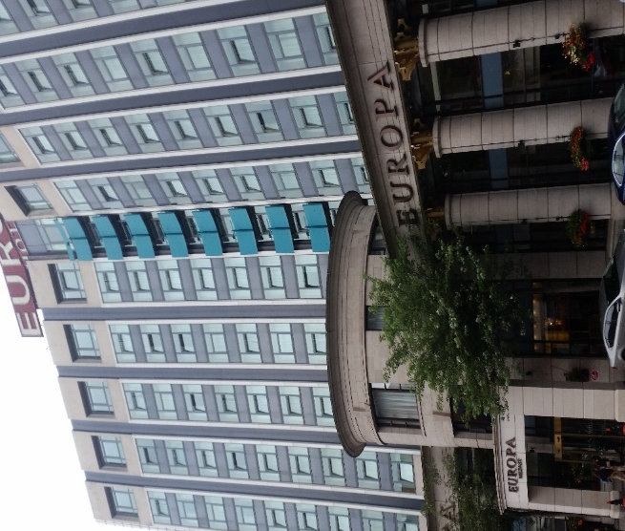
What a contrast from20/30 years ago. Its vibrant, it’s interesting, it’s fun and well worth a visit. Touring the city is like looking into a history book with household names, Shanklin Road, Divis Flats (Military occupied the top two floors) Crumlin Jail and Europa hotel. The fish & chip shop on the Crumlin road where nine people were killed in a bombing is now an estate agent. Europa hotel, the most bombed hotel in Europe, was the only hotel in Belfast. Now there 52 hotels and more being built. Tourists in their thousands and 183 cruise ships visiting this year alone. Yes, its busy but fun. Especially the bars, The Duke of York is a top attraction.

Stormont, the parliament building where the seat of Government sits. Well there has not been a Government for 18 months and the locals are not happy that the people who sit and represent them are still collecting their salary for doing the absolute minimum. Stop their pay and save about £4.52m is the cry. Belatedly they have now lost about 15%.
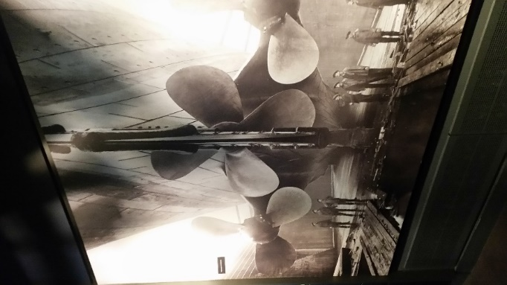
The drive as shown is one mile long. On a sunny day its quite spectacular, we were told!!

Titanic
The locals are keen to tell you that it was built in Belfast and was in good condition when she left their shores. Irish built, English Captain, Welsh purser and a Canadian Iceberg. Fatal combination. The massive Titanic experience is very close to where she was built and launched and is a fantastic tribute to her.
The picture on the right gives a little indication of her size.

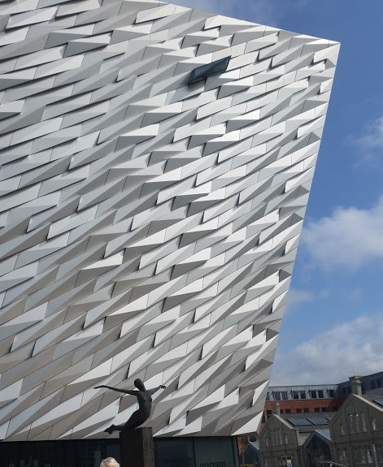
The outside of the experience gives another clue to how large she was. It is actual size of the bow in the photo of the Titanic. Must have been a really big iceberg. Then at 00.15 hrs 12 April 1912 a message to all ships was sent out. CQD, CQD, CQD, CQD, CQD, CQD. MGY was Titanic’s callsign. The first three letters identified the caller as being in distress. Carpathia answered. (Come Quick Distress)

At 00.25 hrs Titanic to Carpathia. The following went out, Come at once. We have struck a berg. This was preceded with the Titanic’s exact location.

Carpathia to Titanic Shall I tell my Captain? Do you require assistance?

Titanic Yes. Come quick.

12.34 hrs Frankfurt to Titanic What is the matter with you?

Titanic, we have struck an iceberg and sinking. Please tell Captain to come.

Frankfurt, Ok. Will tell the bridge right away.

Carpathia was the only ship to pick up survivors. Titanic finally slipped beneath the waves at 02.20 hrs. 15 minutes later she was at rest on the seabed.

Of those lost approx. 690 were crew, 124 x first class, 300 x second class, and disproportionally 530 third class

Titanic had 20 lifeboats these provided space for barely half the passengers and crew.

One ship, the “Californian” was only 20 miles away but did not respond. Why? She saw the flares going up from the Titanic and thought it was some kind of celebration going on. She had shut down for the night due to the ice floes. Her Captain returned to the bridge at 05.00hrs. The Titanic had been gone nearly 3 hrs.

The Carpathian was later to be sunk by U-55 off the coast of Ireland on 17 July 1918 with the loss of 5 crew.

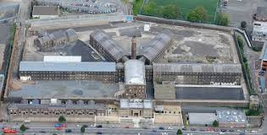
Crumlin Road Jail
This is now a fantastic tourist attraction.

Executions. When originally designed by Lanyon, the prison did not contain gallows and the executions were carried out in public view until 1901, then an execution chamber was constructed within the prison walls and used until the last of the hangings in 1961. Seventeen prisoners were executed in the prison, the last being Robert McGladdery who was hanged in 1961 for the murder of Pearl Gamble.

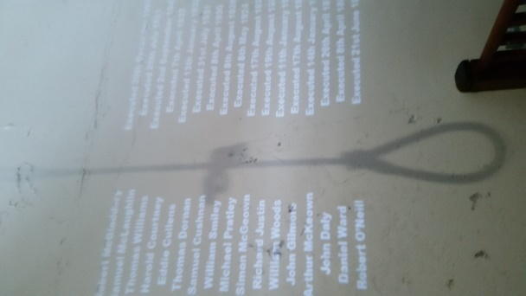
The condemned would live in a cell, large enough for two guards to live in as well. The bodies of the executed were buried inside the prison in unconsecrated ground, against the back wall beside the prison hospital. The execution of Tom Williams, a nineteen-year-old member of the IRA, took place on 2 September 1942; he was hanged for the slaying of an RUC officer. The hangman in charge was Thomas Pierrepoint, the jails most regular hangman, who carried out six executions in the jail between 1928 and 1942. Williams was one of two executed prisoners whose remains were reinterred and buried elsewhere.

It would only take 15 seconds from the moment hand restraints were fitted to the drop on the rope. The execution chamber was behind a sliding wardrobe. The 17 prisoners hanged had no idea death was so close. Practice makes perfect they say….

The Courthouse.
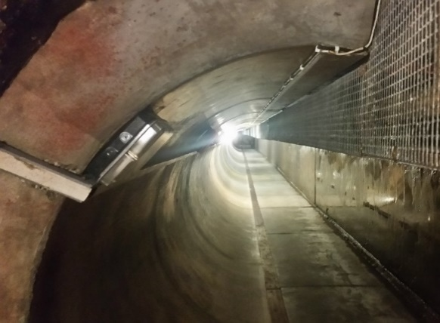
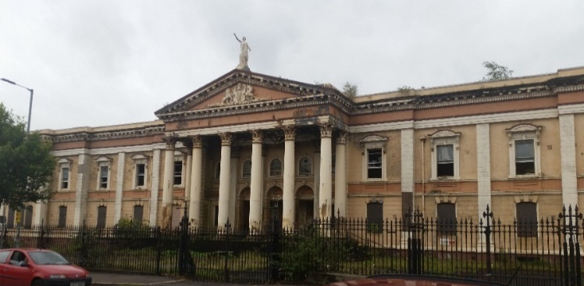
This is situated across the Crumlin road from the jail. Access was via a tunnel of 84 meters in length and 1.5 meters below the road surface. It was constructed in 1849 to coincide with the opening of the Courthouse in 1850. By taking prisoners to court through the tunnel, it was ensured they were kept away from public gaze.
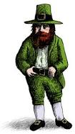
They were held until called in a holding cell where they were individually checked by a senior Prison Officer who would ask a number of specific questions relevant to each prisoner to verify his/her identity before going into the tunnel and then into court.

Mick the Leprechaun in the tunnel

Perhaps the most notorious case the court ever witnessed was the Shankill Butchers. They were an Ulster Loyalist gang, many of whom were members of the Ulster Volunteer Force (UVF). The gang were known in particular for the kidnapping and murdering of random Catholic civilians, who were beaten and hacked to death with butcher’s knives, as the name suggests. By the time the Butchers were brought to justice, they had murdered 19 people and had established themselves as the most prolific gang of serial killers in the United Kingdom’s history. The Crumlin Road Courthouse was host to the trial of the gang’s leader, Lenny Murphy, as well as the trials of various other members of the Shankill Butchers. The 1979 case actually made history, with 11 of the Shankill Butchers being convicted for 19 murders. The 42 life sentences that were handed down by the judge were the most in a single trial ever held in Britain. In 1983.
Crumlin Road Courthouse was once again the location of one of the most notorious cases during the troubles period. 22 IRA suspects were jailed for over 4000 years in 1983, making this one of the most significant and controversial cases Northern Ireland had ever seen. Later Good Friday came along, off you go boys and behave yourselves. Laughable…
The Court House will shortly become yet another hotel. Who would have thought.

War Diary 244 Field Company
26th October 1944
In the early morning 3 Platoon built a Cl 40 40ft Ds bridge in s’Hertogenbosch to give a two-way traffic bridge. The bridge was open at 04.00hrs. During the morning the Company moved forward and harboured close to 282 Field Coy. Later the CRE was wounded and Major Carter assumed the position until Major Bannister was recalled from leave in Brussels

27th
Major Carter was relieved by Major Bannister at about 16.00 hrs. During the evening and night, the Company area received 16 shells from German long-range guns but no damage to personnel or equipment.

28th
At 14.00 hrs the Company HQ and 3Plt moved out of shelled area to a new location. Tac HQ moved to re-join 71 Brigade. In the evening Lt Plummer and Sgt East went out on a recce to a partially demolished bridge all undertaken under Arty and Mortar support fire. They just got to the flood bank to view the bridge, when it was blown by the Germans hurling Lt Plummer into the ditch behind the embankment.

Did you Know
If a deaf person has to go to court, is it still called a hearing?

The first couple to be shown in bed together on primetime television were Fred and Wilma Flintstone.

A pregnant goldfish is called a twit.

Your next meetings are:

Tuesday 9th October

Tuesday 13th November

Tuesday 11th December

Tuesday 8th January 2019
(Subject to confirmation

All of the above starting at 19.30 hours

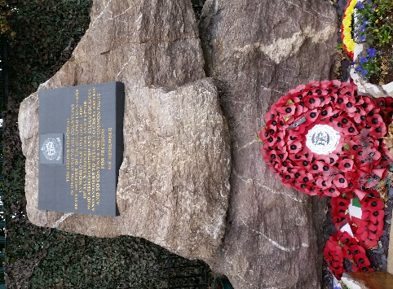

The helper memorial at Eden camp Yorkshire

The Helpers Memorial is dedicated to the countless brave “Helpers” of the occupied countries in World War Two (1939-1945) of all nationalities and faiths who assisted British and Allied escapers and evaders to return to Great Britain and so continue the common fight for Freedom.

WE REMEMBER

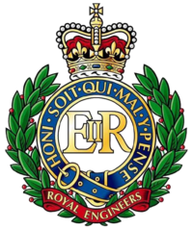

Branch Christmas Lunch

Friday 14 December 2018
Morriston Golf Club

I............................................I will/will* not be attending………… Beef/Turkey*

I will/will* not be accompanied by Name.......................................Beef/Turkey*

I have the following guests
(Full names please)

.............................................................................................................Beef/Turkey*

.............................................................................................................Beef/Turkey*

.............................................................................................................Beef/Turkey*

.............................................................................................................Beef/Turkey*

.............................................................................................................Beef/Turkey*

.............................................................................................................Beef/Turkey*

* Delete where necessary

Returns to me please and payment by 13th November to Roger Jones

