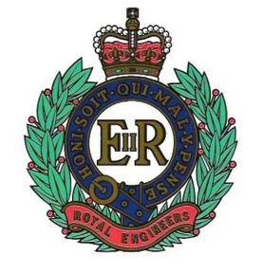 | The Royal Engineers Association |  |  | 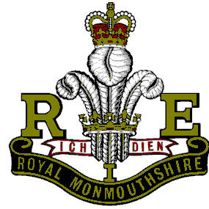
SERVICE NOT SELF |  | PATRON: HER MAJESTY THE QUEEN | CITY OF SWANSEA

Chairman:  Capt (Retd) BD Lawes MBE  64 Lon Coed Bran  Cockett  Swansea  SA2 0YD | President:  Mr Tony Rowlands  256 Dunvant Road  Killay  Swansea  SA2 7SR | Secretary:  Mr A E Adams  Nant-y-Dderwen  Brechfa  Carms  SA32 7BL

Tel: 01792 547644  Email: b.lawes1@ntlworld.com | Tel: 01792 536108  E-mail: tonii@ntlworld.com | Tel: Tel: 01267 202467  Email: anthonyadams186@sky.com

March 2018 Newsletter

Welcome to the 120th edition of your newsletter which I have been compiling since April 2008. I hope I have kept you awake, aware and amused during this time. If there are any complaints or concerns you wish to raise regarding the newsletter then please feel free to pass them on to Tony Adams. He will rectify any irregularities!! Good man Tony.

Future dates for your diary
April
8th: Branch Sunday Lunch. (Morriston Golf Club). Have you booked? It’s not too late.

May
7th; Early Spring bank Holiday.
20th: Whit Sunday.

June
9th: Trooping the Colour, the Queens official birthday.
17th: Father’s Day.

Attendees (February)
Brian Lawes, Tony Adams, Roger Jones, KJ Evans, Nick Beverley, Ron Horsey, George Elliott, Brian Criddle, Tony Rowlands, David Evans and Dave Davie.

Apologies (February) (1)
David Hopkins, the sole contact. I really would appreciate being informed of any non- attendance and to be informed without asking would be great. Foolishly I assume there will be a full house because of lack of contact, only to be disappointed.

Cockleshell Heroes

The Cockleshell Heroes raided Nazi-occupied Bordeaux in December 1942 during ‘Operation Frankton’. The Cockleshell Heroes target was the harbour complex in the city. The port was very important to the Germans as many merchant ships used it to supply the German Army stationed not only in France but also elsewhere throughout occupied Europe. They succeeded in sinking one ship and severely damaging four others and doing enough damage in the port to greatly disrupt the use of the harbour for months to come. Such was the significance of the raid that Winston Churchill said that it helped to shorten World War Two by six months.
Another important reason for ‘Operation Frankton’ to succeed was that German U-boats used the port as a base and any disruption to their Atlantic patrols would have been highly important.

Any German merchant ships that came through the English Channel could be dealt with by either the Royal Navy or by Coastal Command. But plenty of merchant ships were willing to risk sailing to Bordeaux harbour via the Mediterranean Sea and there was little the Royal Navy could do about it. A raid by bombers would have led to many civilian casualties – so this was excluded.

The task of the Cockleshell Heroes was simple – destroy as many ships in the harbour as was possible so that the harbour itself would be blocked with wreckage, thus rendering it incapable of fully operating as a harbour.

The Cockleshell Heroes were from the Royal Marine Boom Patrol Detachment. These men got their nickname from the canoes they were to use which were themselves nicknamed ‘cockles’. After months of training, they set-off for their target on board the submarine ‘HMS Tuna’. Out of the twelve Marines, only Major Hasler, the group commander, and Lieutenant Mackinnon knew where they were going as they had helped formulate the plan. The other ten Marines were only told their target once ‘Tuna’ surfaced off the French coast.

The plan was for the six teams of two men to paddle five miles to the mouth of the River Gironde, paddle seventy miles up it, plant limpet mines on the ships in the harbour and then make their way to Spain.

The raid started badly once the men were due to be dropped off by ‘HMS Tuna’. One of the canoes was holed as it was being made ready on the Tuna. The two Royal Marines who were meant to have used this canoe – called ‘Cachalot’ – could not take part in the raid. It is said that Marines Fisher and Ellery were left in tears at their disappointment.
The commander, Major ‘Blondie’ Hasler partnered Marine Bill Sparks in ‘Catfish’.

As the canoes approached the mouth of the River Gironde they hit a violent rip tide. The waves were five feet high and the canoe ‘Conger’ was lost. The two crew of ‘Conger’ – Corporal George Sheard and Marine David Moffat were towed by the other canoes. Once near the shoreline, both men had to swim to the shore as they were slowing down the remaining canoes. Neither man made it to the shore. It was assumed that they had both drowned.

The crew of the canoe ‘Coalfish’ – Sergeant Samuel Wallace and Marine Jock Ewart – were caught by the Germans, interrogated and shot after being held captive for two days. Despite being in uniform, their captors carried out Hitler’s infamous ‘Commando Order’ – that anyone captured on commando raids was to be shot.

The crew of the ‘Cuttlefish’ – Lieutenant John Mackinnon and Marine James Conway – had to abandon their canoe after it was damaged. They were also caught by the Germans who handed the pair over to the Gestapo. It is though that both men were held and interrogated for about three months before being shot.
The two canoes got to the harbour in Bordeaux. Here they were spotted by a sentry who failed to raise the alarm – possibly he mistook what he saw for driftwood as both crews remained motionless in their canoes as they had been trained to do.

The crews of both remaining canoes placed limpet mines on the merchant ships they found in the harbour. This whole process took about two to three hours. Each mine had a nine-hour fuse on it that was activated before the mine was placed giving the four Marines time to get away. Both ‘Crayfish’ and ‘Catfish’ escaped on the tide.

The damage to Bordeaux harbour was severe. Now the crews had to leave their canoes, move on foot and link up with the French Resistance at the town of Ruffec. The Germans automatically assumed that the men would travel south to Spain. In fact, they travelled 100 miles north of Bordeaux – a journey that took six days. They then backtracked and travelled to Gibraltar via Spain.

Laver and Mills, who were moving separately from Sparks and Hasler, were caught by the Germans and shot. With the help of the French Resistance, Hasler and Sparks reached Spain and then Gibraltar – a journey that took a total of fifteen weeks.

Even here, Sparks met problems. Hasler was transported back to Britain with due speed on the orders of Lord Louis Mountbatten. However, Sparks did not have such luck and was arrested because he could not prove his identity. Sparks was transported back to London where he was put under guard by the military police. However, Sparks slipped these guards at Euston Station. He visited his father to assure him that he was not dead and then made his way to the Combined Operations Headquarters.

The Spitfire (Some facts)

At the height of the Battle of Britain the Germans were sustaining ever increasing losses. Reichsmarschall Herman Goring called for the top German fighter ace, Adolf Galland and asked what he needed to overcome these losses. Give me a squadron of Spitfires was his reply. The climax of the Battle of Britain came on September 15th when the Germans lost 56 aircraft forcing Hitler to abandon his plans to invade Britain.

The Spitfire production line in 1936/7 at Castle Bromwich for making the aircraft was pitiful, the plant was meant to have built 1.000 Spitfires within two years but by June 1940 not one aircraft had been built. New management was installed under the Vickers industrial giant and soon the factory was operating efficiently. At its peak in 1943 the 14,000 work-force of which 40% were women were turning out 300 aircraft a month.
The Spitfire bowed out of RAF service in Hong Kong in 1955. In a twist of history, the Spitfire was involved in the Arab-Israeli conflict of 1948-9. It was in use by both forces, in January 1949 thee Mk XVIII’s were shot down by Israeli Spitfires.
The greatest ace flying of this aircraft was James Edgar “Johnie” Johnson. He is credited with 38 confirmed kills and a more remarkable fact he was never shot down despite flying more than 1,000 missions. His Spitfire was damaged only once.

Max speed was 355 mph dependent on variant.
Mission range of 470 miles.
Service ceiling 36,500ft. (There is one at RAF Coningsby reputed to have reached 53,000 feet) A visit to the Battle of Britain Memorial Flight is a must.
Spitfire production overall 22,789 were built with 19 Marks and 52 variants. The most produced variant the Mark IX with 5,665. But was the Spitfire the true hero of the Battle of Britain? Next month the Hurricane.

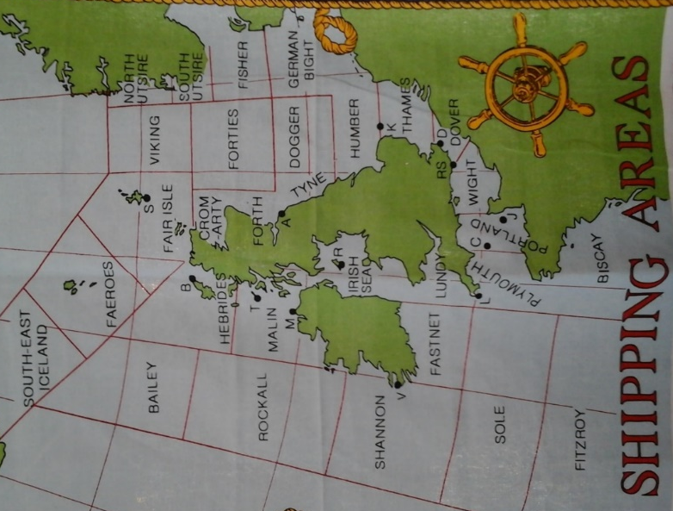
Shipping forecast as on Radio 4
For all you sailors out there.

Operation Anthropoid (continued)

The assassination attempt
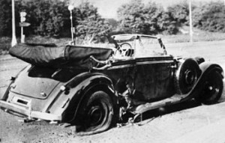
Officers Jozef Gabčík and Jan Kubiš were positioned at the tram stop near Bulovka Hospital where there was a bend in the road while their colleague Josef Valčík signaled with a mirror the arrival of Heydrich’s open-roofed Mercedes Benz. Gabčík jumped in front of the vehicle, but his sten gun jammed. Heydrich had his car stopped and tried to shoot Gabčík when Kubiš hurled a grenade.
The grenade fell short and exploded outside the car, however Heydrich suffered a broken rib, ruptured diaphragm and splinters in his spleen, and Kubiš was injured as well. The explosion shattered the windows of a tram as shards of glass maimed passengers. Though severely injured, Heydrich tried to chase Gabčík but soon collapsed.
The driver Klein raced after Kubiš, but his gun jammed, and the resistance fighter got away. Following Heydrich’s orders, Klein then set after Gabčík, who hid in a butcher’s shop. The owner, a Nazi sympathizer, revealed his hideout to Klein, who collided with Gabčík in the shop. The assassin injured the driver in the leg and scurried away to safety. The 38-year old Heydrich was taken to nearby Bulovka hospital where he died June 4 at 4:30 am.

The manhunt
The assassination triggered the greatest manhunt in the history of the Third Reich. The Gestapo knew they were on the hunt for parachutists due to an unused bomb with British parts and a British sub-machine-gun abandoned at the scene. The Nazis offered a reward of one million marks for the Czechs’ arrest. Martial law was proclaimed, and everyone over the age of 15 had to register with the police by May 30, or they would be shot. Evidence left at the scene was displayed in the window of Baťa shoe store on Wenceslas Square. Some 21,000 Germans searched over 36,000 houses but came up empty.

The Battle at the Cyril and Methodius Church
After taking refuge with two Prague families, the assassins, along with five other paratroopers, hid in the Karel Boromějský Greek Orthodox Church in Prague’s New Town. Resistance fighter Karel Čurda betrayed them, and 700 German soldiers pounced upon the church. Three resistance fighters, including Kubiš, were killed in the prayer loft after a battle that lasted two hours, even though the Czechs only had pistols and the soldiers were armed with sub-machine guns and hand grenades. After a preacher revealed that the others were hiding in the crypt, the soldiers tried to seize the catacombs, flood the space and smoke out the assassins. Finally, after holding out for six hours, the four parachutists, including Gabčík, committed suicide.

German reprisals: Lidice and Ležáky
The Germans unleashed a severe retaliation. Hitler lashed out by murdering thousands of Jews. He wanted to kill 10,000 Czech political prisoners, but high-ranking Nazi and military commander Heinrich Himmler convinced him that they needed the Czechs to keep the Protectorate industrially productive. Still, more than 13,000 were arrested, and 5,000 were murdered in reprisals. Due to false information, the Nazis thought the assassins were hiding in Lidice, a village near Prague, and also found a radio resistance transmitter in Ležáky. The Germans took revenge on Lidice by killing all 199 men in the town, arresting the 195 women and sending them to Ravensbrück concentration camp and taking the 95 children, eight of whom were given to German families. Most of the children disappeared; in all probability they were gassed. Lidice was razed on June 9, 1942, and the ruins were bulldozed. The revenge on Ležáky was a nightmare as well. All the adults were murdered while the children disappeared, except for two who were handed over to Nazi families. The town was as Lidice razed to the ground.

Did you Know?
Tottenham won the FA Cup as a non-league side beating Sheffield Utd 3-1 in a replay following a 2-2 draw on 21st April 1901. They are to date, the first and last non-league side to achieve this. The replay was at Burnden Park Bolton in front of 20,704. The first game at Crystal Palace had a crowd of 114,815.

Years gone Bye

1918
3rd: Turkey: The entire male population of the Armenian town of Samsun is massacred by Muslims.
7th: Moscow: The Bolsheviks change their name to the Russian Communist Party.

9th: London: New Military Service Bill raises maximum conscription age to 50 and introduces conscription for Ireland.

1958
1st: Turkey: At least 220 people drown when a ferry sinks.

6th: UK: The TUC and Labour party call for an end to H-bomb testing.

20th: London: The bank rate is cut from seven to six percent.

1968
8th Poland: Police clash with student demonstrating for greater freedom.

10TH: New Zealand: 200 are feared dead when a car ferry capsizes in Wellington harbour during a severe storm.

27th: London: Michael Stewart says Britain will not transfer sovereignty of the Falkland Islands without the islander’s consent.

Your Next meetings are
March 13 (AGM)
April 10
May 8
June 12

