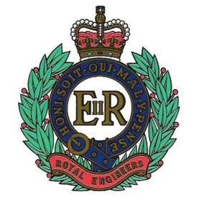  … | The Royal Engineers Association |  |  | 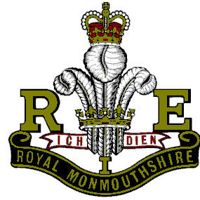
SERVICE NOT SELF |  | PATRON: HER MAJESTY THE QUEEN | CITY OF SWANSEA

Chairman:  Capt (Retd) BD Lawes MBE  64 Lon Coed Bran  Cockett  Swansea  SA2 0YD | President  Mr Tony Rowlands  256 Dunvant Road  Killay  Swansea  SA2 7SR | Secretary:  Mr A E Adams  Nant-y-Dderwen  Brechfa  Carms  SA32 7BL

Tel: 01792 547644  Email: b.lawes1@ntlworld.com | Tel: 01792 536108  E-mail: tonii@ntlworld.com | Tel: 01267 202467  Email: anthonyadams186@sky.com

April 2018 Newsletter

Could this be the beginning of the end to winter and an introduction to a long warm/hot summer. My brolly is shattered after all the work its done. Can the Swans beat the dreaded drop and can Norwich come good again before the end of the season?
As always I am still looking and waiting for stories from you for inclusion into the newsletter. Come on there must be something out there however sad/funny. As Delia Smith once said “C’on lets be aving you”. Norwich went on to lose 3-0 to Man City!!

Attendees (March)
Brian Lawes, Tony Adams, Roger Jones, KJ Evans, Nick Beverley, George Elliott, Ron Horsey, David Evans, David Hopkins, Peter Wade, Gerry Walsh, Tony Rowlands and Ossie Simmons.

Did you Know?
The longest animal in the sea is actually a jellyfish. The “Lions Mane” jellyfish has been known to have tentacles up to 120 feet in length.

The Messerschmitt 109 when first developed and during initial trials was powered by a Rolls Royce Kestrel VI engine until such time they developed their own. Over 32,000 109’s were built by the end of the European phase of the war. The most produced fighter in history.

Smile for the Day
“I’d like to start with the chimney jokes – I’ve got a stack of them. The first one is on the house.”
“I’ve decided to sell my Hoover – it was just collecting dust.”

“I’ve just been on a once-in-a-lifetime holiday. I’ll tell you what, never again.”
“My definition of an intellectual is someone who can listen to the William Tell Overture without thinking of the Lone Ranger.”
“I’ve always wanted to go to Switzerland to see what the army does with those red knives.”

The Hurricane

This aircraft was the real workhorse of the RAF contrary to popular belief regarding the Spitfire. For every two Luftwaffe aircraft shot down by the Spitfire, three were destroyed by the Hurricane. During the Battle of Britain the Hurricane accounted for 55% of all kills.

The only VC awarded during the Battle of Britain was to pilot James Nicholson. It’s incredible that it happened on his very first combat mission in mid-August 1940. On reaching an altitude of 18,000 feet his Hurricane was hit by four cannon shells from a Messerschmitt 110. The attack left him badly injured with splinters in his eyes and blood pouring form his legs. The plane was soon engulfed in flames, but just as he was about to bale out the 110 came into his gunsight. In an incredible display of indifference Nicholson sank back into his seat and pressed the gun button. He kept up the pursuit against the stricken 110 even as the skin was peeling from his hands. With the throttle pushed open speeds of up 400 mph were recorded. One further burst from his machine guns sent the 110 from the sky, he then managed to leap from his burning Hurricane. On his descent he was fire on by a Home Guardsman firing an antiquated airgun, some pellets hitting him in the backside. After recovery he went back on combat duty.
Fully recovered by September 1941, Nicolson was posted to India in 1942. Between August 1943 and August 1944 he was a Squadron Leader and C.O. of No 27 Squadron, flying Bristol Beaufighters over Burma. During this time he was awarded the Distinguished Flying Cross.
As a Wing Commander, he was killed on 2 May 1945 when a RAF B-24 Liberator from No. 355 Squadron, in which he was flying as an observer, caught fire and crashed into the Bay of Bengal. His body was not recovered. He is commemorated on the Singapore Memorial.
There were many variants of the Hurricane but nothing like the numbers for the Spitfire.
Mk1 with a Rolls Royce Merlin engine and eight .303 machine guns and loaded with 2,600 rounds. It could be reloaded in under 3 minutes.
Mk1 revised with metal covered wings and a constant speed metal propeller. 4,200 were built.
MkIIA with a MerlinXX two speed supercharged engine.
MkIIB with 12 Browning machine guns
MkIIC with four 20mm Hispano cannons, 2 on each wing (4,711 were built}
MkIID with two Vickers 40mm cannon for tank busting. (Nicknamed the flying can opener}
A total of 14,533 of various Mks were built. The second largest total for any British aircraft after the Spitfire.
Durability of the plane meant that it was easy to repair. No fewer than 60 per cent of all Hurricanes that were shot down or crashed on British soil were sent back into service with Fighter Command. It’s the only aircraft to see action in every British theatre during the war. Indeed, more than 2,000 Hurricanes served on the Eastern front with the Russians.

A sea going variant was developed called the Hurricat. These were developed, to be catapulted from merchant ships during the Battle of the Atlantic.

It held the world air speed record in February 1938 when on a power trial, flew at 408.7 mph from Edinburgh to London. It’s been estimated it took 170,000 hours of design, development and construction to get the Hurricane ready for squadron service, compared to 300,000 man hours for the Spitfire.

Sydney Camm the chief design engineer said of the Hurricane in a post war interview, without those Hurricanes you and I would not be sitting here today.

Next Month the Lancaster

Years gone Bye (April)
1918

6th: Far East: British and Japanese troops land at Vladivostok, one day after the arrival of US Marines.

19th: Rome: Italy tells the Allies that it has sent troops to fight at the Western Front.

23rd: North Sea: British forces raid the Belgium seaports of Zeebrugge and Ostend, bottling up the two submarine bases.

1958
4th: London: 3,000 anti-nuclear protesters set out on a march to Aldermaston.

10th: UK: A Roman mosaic pavement has been unearthed at the site of a Roman villa in Sussex.

21st: US: 49 die when two planes collide over Nevada.

1968
4th: US: Dr Martin Luther King is shot dead in Memphis.

6th: Canada: Pierre Trudeau becomes Liberal premier.

20th: South Africa: 122 died when a London bound Boeing 707 crashes.

100 Years of the RAF

To celebrate the centenary of the RAF a service is being held in St Mary’s on Saturday 21 April at 10.30hrs. Followed by a parade including a march past and a flypast in and over Swansea City centre. The Branch are not part of the parade. Attend as a spectator if you wish.

The Battle of Britain

The Battle of Britain was ultimately a test of strength between the German Air Force (Luftwaffe) and the RAF. The RAF had become an independent branch of the British armed forces in 1918. Although it developed slowly in the years following the First World War, it went through a period of rapid expansion in the latter half of the 1930s – largely in response to the growing threat from Nazi Germany. In July 1936, RAF Fighter Command was established under the leadership of Air Marshal Sir Hugh Dowding. Germany had been banned from having an air force after the First World War, but the Luftwaffe was re-established by the Nazi government and by 1940 it was the largest and most formidable air force in the world. It had suffered heavy losses in the Battle of France, but by August the three air fleets that would carry out the assault on Britain were at full readiness. The RAF met this challenge with two of the best fighter aircraft in the world – the Hurricane and the Spitfire.

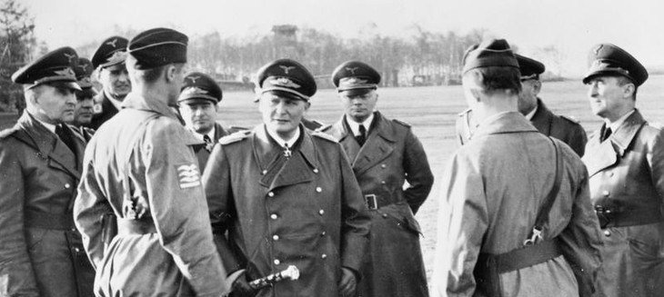

Is this the moment when Goering was asked for a squadron of Spitfires to help win the battle for Britain?

Nearly 3,000 men of the RAF took part in the Battle of Britain – those who Winston Churchill called ‘The Few’. While most of the pilots were British, Fighter Command was an international force. Men came from all over the Commonwealth and occupied Europe – from New Zealand, Australia, Canada, South Africa, Rhodesia (now Zimbabwe), Belgium, France, Poland and Czechoslovakia. There were even some pilots from the neutral United States and Ireland. Two of the four Group Commanders, 11 Group’s Air Vice-Marshal Keith Park and 10 Group’s Air Vice-Marshal Sir Quintin Brand, came from New Zealand and South Africa respectively. The War Cabinet created two Polish fighter squadrons, Nos. 302 and 303, in the summer of 1940. These were followed by other national units, including two Czech fighter squadrons. Many of the RAF’s aces were men from the Commonwealth and the highest scoring pilot of the Battle was Josef Frantisek, a Czech pilot flying with No. 303 (Polish) Fighter Squadron. No. 303 entered battle on 31 August, at the peak of the Battle of Britain, but quickly became Fighter Command’s highest claiming squadron with 126 kills.

During the Battle of Britain, the Luftwaffe was dealt an almost lethal blow from which it never fully recovered. Although Fighter Command suffered heavy losses and was often outnumbered during actual engagements, the British out-produced the Germans and maintained a level of aircraft production that helped them withstand their losses. The Luftwaffe, with its lack of heavy bombers and failure to fully identify critically important targets, never inflicted strategically significant damage. It suffered from constant supply problems, largely as a result of underachievement in aircraft production. Germany’s failure to defeat the RAF and secure control of the skies over southern England made invasion all but impossible. British victory in the Battle of Britain was decisive, but ultimately defensive in nature – in avoiding defeat, Britain secured one of its most significant victories of the Second World War. It was able to stay in the war and lived to fight another day. Victory in the Battle of Britain did not win the war, but it made winning a possibility in the longer term.

More than 1700 Luftwaffe planes were destroyed. The 2662 German casualties included many experienced aircrew, and the Luftwaffe never fully recovered from the reverse it suffered in August-October 1940. The Royal Air Force (RAF) lost 1250 aircraft, including 1017 fighters.

Next Branch Meetings are on

Tuesday 10th April

Tuesday 8th May

Tuesday 12 June

Tuesday 10th July

All Starting at 19.30 hrs

The Branch has a guest speaker at Aprils meeting. Wayne Tucker from SW Police will be giving up his time and a 40 minute presentation into policing matters. And to answer your questions. If any. Hopefully the Branch will turn out for this in large numbers. I hope so.

